**1. Supervised learning**

Hi! My name is Hadrien, I'm a Content Developer here at DataCamp. Great job on Chapter 1! Now that you know more about machine learning, let's dive in deeper.

**2. Modeling**

Machine Learning is all about modeling. Not that kind of modeling.

**3. Types**

As you saw in Chapter 1, there are several types to machine learning, including supervised learning.

**4. What is supervised learning?**

Supervised learning is basically a labeling machine. It takes an observation, and assigns a label to it.

**5. Classification and regression**

There are two flavors of supervised learning: classification and regression.

**6. Classification**

Let's focus on classification first.

**7. Classification**

Classification consists in assigning a category to an observation. We're predicting a discrete variable, a variable that can only take a few different values. Is this customer going to stop its subscription or not? Is this mole cancerous or not? Is this wine red, white or rosé? Is this flower a rose, a tulip, a carnation, a lily?

**8. Observations**

Remember, we feed the model observations. Let's take college admissions where we want to predict acceptance.

**9. Features**

For simplification, we show two features here: GPA and admission test results. We could have more features like: involvement in student organizations and sports or prizes applicants have won.

**10. Target**

And, the target is what we want to predict. There are two possible labels: those who are accepted and those who are not. The target can only be one of these two labels, making it a classification problem.

**11. Graphing our data**

Here are our observations plotted. GPA on the x axis and test results on the y axis. Blue points represent accepted applicants, red points represent rejected applicants.

**12. Splitting data**

We keep 80% of our data to train our model.

**13. Manual classifier**

Because we use just two features, we're able to plot and interpret the results. For us humans, it's pretty clear. If you score above 4 on both the GPA and entrance test, you're accepted. If we added more features like extracurriculars or prizes, we would need more axes. It would be very hard for us to interpret the data with our human eye. However, an model wouldn't struggle at all. We can use a Support Vector Machine. It sounds scary, but it's just a line separating our points.

**14. Support vector machine - linear classifier**

We train our algorithm and classify the 20% of observations we left aside. It only misclassifies two blue points as red - meaning two applicants were wrongly predicted as rejected. The problem is, it tries to separate with a straight line, so it's unlikely to do better than that.

**15. Support vector machine - polynomial classifier**

What if we allow a curved line instead? Then it classifies everything correctly! There are ways we can tweak our model's behavior, like allowing curves. We will talk about that later.

**16. Regression**

Now, what about regression?

**17. Regression**

While classification assigns a category, regression assigns a continuous variable, that is, a variable that can take any value. For example, how much will this stock be worth? What is this exoplanet's mass? How tall will this child be as an adult?

**18. Predicting temperature**

Let's look at some new data: weather readings. Can we predict temperature based on humidity?

**19. Training data**

We use 80% of the data to train our model. Seems like when humidity rises, temperature decreases.

**20. Linear regression**

Indeed, our linear regression model catches that.

**21. Model**

Making this is our model.

**22. Given humidity...**

According to our model, if the humidity rate is 0.5,

**23. ...find temperature**

Then the temperature is 18.5 ?C.

**24. Testing data**

And this is how the model performs on real data. It identified the trend, but is still bad at predicting. More features, like wind, cloudiness, location, season could make it more accurate.

**25. Classification vs regression**

It's up to you to choose whether you want to frame your problem as a regression or classification problem. For example, we could predict an exact temperature, or a categorical range of temperatures like "Cold", "Mild", and "Hot". This is true for something like age, where we can have categories like baby, child, teenager, adult, and so on! Do you see the difference?

**26. Let's practice!**

Let's make sure everything is clear with some exercises.

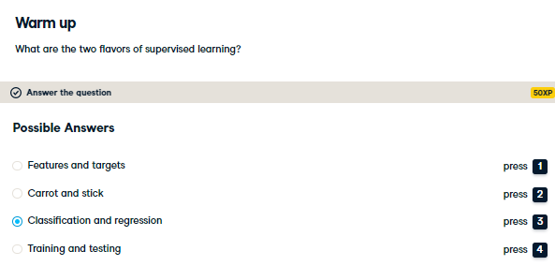

Exactly! Let's try something a little more challenging then.

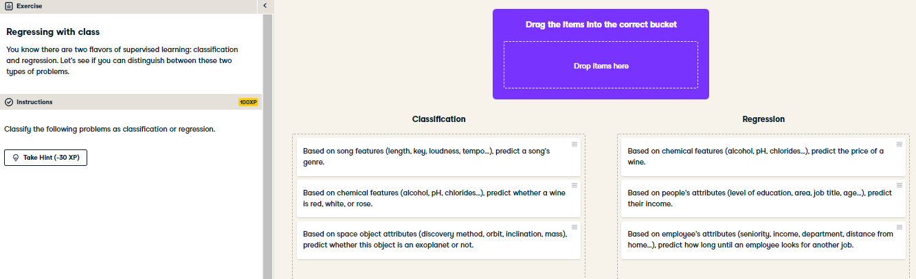

Excellent! Seems like you're grasping the difference between classification and regression quite well. Let's talk about unsupervised learning then!